Post-Implementation of Portal
Aaron R. Smith
Western Governors University

Table of Contents
Summary 3
Review of Other Work 6
Changes to the Project Environment 9
Methodology 10
Project Goals and Objectives 12
Project Timeline 14
Unanticipated Scope Creep 16
Conclusion 16
References 19
Appendix A 20
Project UI Design Wireframe 20
20
Appendix B 22
Network and Systems 22 22
Appendix C 23
Training Material Sample 23
23

Summary

Texas Grocers is a state-local grocery retailer operating approximately 300 stores across Texas and employing about 85,000 associates. Texas Grocers currently relies on a legacy, outdated closed system that prevents efficient, seamless access to work-related applications, programs, and information. Employees require seamless, real-time access to their inventory management, workplace scheduling, and training and development tools, as well as to internal communications channels and an HR portal for miscellaneous company information. The legacy system is desktop-specific, requires workplace PCs on the internal WLAN, and is unavailable, particularly for those who work across multiple storefronts, need responsive access outside (usually via mobile device), or need on-demand work inside. There is a genuine productivity and efficiency barrier, alongside increased overburdening of lower and higher levels of administration, data and system errors, whether in inventory counts or simply in someone's work schedule, and widespread discouragement in the workplace.

The IT solution projected, designed, produced, and implemented is a unified, secure work portal application that allows employees to access work-related applications and programs via their work portal on any device within their WLANs. This centralized web-based dashboard operates as a single sign-on (SSO) gateway with a responsive UI/UX that reflects the company's logo, culture, and user preferences. It centralizes and unifies the platform, provides appropriate access for users, and covers everything related to Texas Grocers. The workforce portal is compatible with existing company infrastructure, allows integration and cross-device compatibility, is accessible from mobile devices and desktops, and maintains RBAC integrity while allowing users to perform their tasks and view, modify, and create only what is needed, not more or less.

The project followed a hybrid Waterfall-Agile methodology over the 13-week timeline. The planning and requirements phase gathered detailed requirements through stakeholder analysis and the current systems workflow. The respective IT teams established wireframes and diagrams to separate and define functional and non-functional requirements and preferences. The design phase created a responsive, company-themed, user-friendly, and centralized UI with a database structure and logic that follows best practices for the company's WLAN and application. Development built the interface along with the database and backend services while integrating the old system where possible and introducing core features iteratively. Users or stakeholders use testing and judgment to evaluate metrics such as load times, compatibility issues, success, productivity boost, and security audits. The functional, finalized build was implemented and documented, deployed within selected stores, and gradually rolled out to others, along with a finalized document, a demo, an FAQ, and a glossary. The review/closing phase reflected on lessons learned and evaluated whether the respective IT teams followed best practices to achieve the outcome.

This proposed solution directly resolves the problems by eliminating multiple logins, removing device and location restrictions, and modernizing the legacy platform, without the expense and capital required to acquire additional infrastructure and systems. The overall post-implementation outcome is measurable success, demonstrated by metrics and noticeable real-time changes in workplace results. Productivity increased measurably in the workplace; baseline productivity metrics significantly increased, while helpdesk tickets decreased, error rates decreased, and overall user satisfaction scores increased, including real-time positivity. The workforce portal now provides a consistent, secure, and user-friendly experience that fully aligns with Texas Grocers' operational strategy and organizational culture. This capstone project fully meets the requirements of the Bachelor of Science in Information Technology degree emphasis by demonstrating exemplary competencies in systems analysis, application development, API integration, security, networking, and project management.

Review of Other Work

Torres, Gurley, Purkayastha, and Albesher wrote scholarly articles that appropriately align with the project; the respective IT team analyzed these scholarly articles to ensure the project was evidence-based, realistic, and aligned with IT best practices. The four works chosen directly resonate with the project's critical pillars: self-service, single sign-on systems (SSOs), enterprise authentication, and integration management systems.

Torres Rico (2023). – In the scholarly article "Understanding the Impact Self-Service Technology (SST) Has on Employee Outcomes and Perceptions," the author examines how SST implementations in retail settings affect storefront employee productivity, job satisfaction, and self-service influence, along with their perceptions. Mixed-methods-generated data from medium- to enterprise-scale grocery stores indicate that methodically designed SST portals significantly reduce administrative overhead, improve operational and functional efficiency, and positively influence employee morale when properly trained and integrated. Initial challenges are mostly employee resistance, but ongoing support numbs it down, as employees respond positively to positive reinforcement.

Gurley (2021) – The scholarly work “Strategies for Implementing Self-Service Technologies in Supermarket Retail Operations” presents a multiple-case study of supermarket managers adapting SST for checkout and back-office functions. Core insights, holistically, emphasize that a successful rollout requires transparent management strategies, employee training programs, and methodical deployment to maintain consistent employee satisfaction throughout their career. Gurley's research concludes that measurable gains in operational efficiency and cost savings materialize when SST carefully aligns with existing organizational workflows, provided a structured, methodical planning process is approached and implemented.

Purkayastha et al. (2017). – The peer-reviewed article "Implementation of a Single Sign-on System Between Practice, Research, and Learning Systems" documents a real-world deployment of SSOs in a large healthcare enterprise. Purkayastha reports substantial reductions in password-related helpdesk tickets (approximately 70%), time savings for end users (averaging 9.5 minutes per day), and improved security compliance. This conclusive study additionally outlines technical and organizational best practices for integrating SSO across disparate legacy systems.

Albesher (2024) – In the scholarly article “Toward Secure Mobile Applications Through Proper Authentication Methods,” published in PeerJ Computer Science, the researcher compares authentication flows across 50 enterprise and e-commerce mobile applications. Findings stress the importance of WLAN-restricted access, encrypted sessions, and responsive design to mitigate risks in distributed environments. The work provides practical guidelines for balancing usability with security in cross-device enterprise portals.

These four scholarly works inform and infer critical aspects of the Texas Grocers portal design. Torres Rico (2023) inspired the inclusion of robust user-centric testing and training components by emphasizing the need to address frontline employees' perceptions early, before prolonged bitterness sets in. The proposal integrates multiple iterative beta releases and stakeholder feedback loops to support progressive, calculated reasoning. This approach aims to foster strong end-user adoption and positive employee outcomes, therefore, minimizing potential disruptions and increasing productivity. Gurley (2021) shaped the project's waterfall-based strategy, management approach, and elements. This influence led to pilot-store deployments and comprehensive training documentation to address high turnover and varied shifts. Purkayastha et al. (2017) blueprinted the SSO and integration architecture; the documented variables, such as productivity and security gains, justified centralized authentication within the WLAN. The design choice directly supports the core features and the intended time savings. Albesher (2024) built upon security and responsive design decisions that align with strict network controls and cross-device compatibility, thereby preventing common authentication vulnerabilities. Overall, these works help validate the project's scope and chosen methodology and provide an evidence-based rationale for expected outcomes such as 20–50% productivity improvements and reduced administrative overhead.

Changes to the Project Environment

The current project environment at Texas Grocers is a hybrid of legacy and modern infrastructure, which is typical of small- to medium-sized retailers. The existing systems consist of on-premises inventory and databases, with a moderate mix of vendor-provided schedule and training platforms and applications. A corporate-level WLAN is in place, using Wi-Fi and Ethernet standards and protocols for both front- and backend services. The company supports an associate-led culture, emboldening them to do their best in terms of speed and effort, which is difficult with the legacy system alone. Texas Grocers wants to remain competitive without changing its associates; it can do so through targeted tools that boost employee experience and reduce overhead.

The implemented workforce portal has transformed this environment into a modern, centralized, and secure work environment. Existing systems were retained and integrated via connected APIs rather than replaced; this choice preserved existing organizational knowledge and minimized total cost. The portal now serves as the single entry point, enforcing RBAC, centralized logging, and MFA. Infrastructure changes were limited to adding backend application servers and enhancing monitoring tools. The solution fully aligns with the company's culture by empowering associates with mobile-friendly access, supports the strategy of operational excellence and scalability, and positions Texas Grocers for future enhancements such as AI-driven scheduling or analytics. No major disruptions occurred during rollout due to the careful phased approach.

Methodology

A hybrid Waterfall-Agile methodology was planned and implemented in the project. The waterfall provides a solid structure and documentation required for enterprise governance and compliance, while the agile method provides sprints for rapid iteration and incorporation of stakeholder feedback. This project is the green light for enterprise portal applications, as it balances predictability with adaptability.

Executable steps:
- Requirements Gathering – Discovery, stakeholder interviews, and current-environment analysis (weeks 1-2).
- Detailed Design – Wireframes, diagrams, architecture reviews, and security reviews (weeks 3-4).
- Iterative Development – Weekly sprints to build core modules and functions, along with integration and UI building. Team meetings, reviews, and ideas (weeks 5-7).
- Continuous Testing – Audited test with user-acceptance testing with pilot users (weeks 8-9).
- Phased Deployment – Rollout to chosen pilots, followed by stakeholder and rollback plans (weeks 10-11).
- Post-Implementation Review – Lessons learned, metric collection, and knowledge of documentation, transfer, and sign off (week 11-12).

There are various tools, such as version control systems like Git, communication tools like Microsoft Teams, and formalities to ensure audibility and quality.

Note: Steps 4 and 5 are iterative (not necessarily before or after, but together and revisited), allowing additional crunches within sprints, in time management, along with potential creeps.

Project Goals and Objectives

Goal 1: Develop, produce, and deploy a secure, available, and responsive work portal application that enables Texas Grocers associates to access required and optional applications and information from any device while connected to the company’s internal WLAN. Objectives:
- Develop and design an interface that reflects the company’s culture, brand, and user preferences. The deliverable is a fully branded, available, and responsive frontend source with accessibility options.
- Unify and centralize the platform, provide appropriate access for users based on roles, and ensure accessibility and alignment with company culture. The deliverable is a main dashboard that integrates old and new modules, with role-based enforcement.

Goal 2: Modernize the legacy system by keeping what is needed and integrating it with the “new system” API to address issues in the legacy system. Objectives:
- Full cross-device compatibility and integration with the current systems environment must be fully functional and operational. The deliverable is an API integration layer and zones. They will have audited metrics for test reports.
- The role-based culture must be maintained; therefore, the role-based system must have appropriate execute, modify, and read permissions across all policies and groups. The deliverable is a role-based policy and a group-focused matrix that will include logs and audits.

Goal 3: A documented solution with measurable metrics that must match the expected outcomes. The assigned team will create artifacts and documents for lessons learned, FAQs, and “transferable knowledge”. Objectives:
- Iterative stakeholder meetings and reviews throughout the development and testing of the project. The deliverable is a feedback summary, including reports, changes, and outcomes, for each milestone and pilot.
- A final deployment, including training demos and material, and an outcome summary with metrics. The deliverable is a functional, operational application with FAQs and demos, as well as a quality-quantitative metrics dashboard.

All goals and objectives were accomplished. The table below provides a met/unmet assessment for each objective:
Goal: | Objective: | Status: | Assessment:
Goal 1 | Develop a branded responsive frontend. | Met | Completed with UI/UX aligning to company branding; tested for cross-device compatibility and accessibility.
Goal 1 | Centralized dashboard with RBAC. | Met | SSO gateway and role-based policies fully implemented and audited.
Goal 2 | API integration and cross-device compatibility. | Met | Full integration layer built; compatibility verified across devices during testing.
Goal 2 | Maintain RBAC permissions. | Met | Policy matrix and audit logs were created and enforced.
Goal 3 | Iterative stakeholder feedback. | Met | Multiple review meetings held; feedback incorporated into sprints.
Goal 3 | Final deployment and documentation. | Met | Phased rollout completed; training materials, FAQs, and metrics dashboard delivered.

Project Timeline

The project was executed over 12 weeks, beginning shortly after approval on 12/01/2025:
Milestone/Goalpost. | Planned Duration | Actual Duration | Actual Start | Actual End Date
Planning/Requirements. | Two weeks. | Two weeks. | 12/01/2025. | 12/015/2025.
Design. | Two weeks. | Two weeks. | 12/16/2025. | 12/30/2025.
Development. | Three weeks. | Three weeks and four additional days. | 12/31/2025. | 01/25/2026.
Testing/Beta. | Two weeks. | One week, plus three additional days. | 01/26/2026. | 02/05/2026.
Implementation/Documentation. | One week. | One week. | 02/06/2026. | 02/13/2026.
Review/Closing. | One week. | One week. | 02/14/2026. | 02/21/2026.

- Weeks 1-2: Planning and Requirements – Completed requirements and wireframes.
- Weeks 3-4: Design – UI/UX and architecture finalized.
- Weeks 5-8: Development (Approximately, plus four additional days, due to creep) – Core features and integrations built.
- Weeks 9-10: Testing and Beta (Approximately, minus four days from final week, time saved from agile sprints) – Feedback incorporated and issues resolved.
- Week 11: Implementation and Documentation – Phased rollout and deliverables completed.
- Week 12: Review/Closing – Final evaluation and handover.

All milestones were met on schedule, with the final deployment completed by the end of week 12 (approximately 02/21/2026). Slight variances occurred between projected and actual dates, but we were able to maintain scheduled weeks. During the development phase, issues with vendor systems arose due to poor documentation and custom API middleware. However, fortunately, after an additional 4 days, they were resolved through communication with the initial vendor. In the Testing and Beta phase, four days were redirected, as agile and iterative work allowed efficient tracking back on schedule. Team members worked together to test the workforce portal for issues at a rapid pace and in brain-crunch mode, rather than solely relying on the beta for piloted stores. Overall, the time was met on track, despite slight variations.

Unanticipated Scope Creep

Two minor instances of scope creep occurred. The first creep was additional compliance requirements for enhanced audit logging and data privacy controls (driven by an internal legal review), which required additional development effort. The second creep was that one legacy vendor system required custom API middleware due to incomplete documentation and poorly executed work. These scope creeps prolonged the Development phase by approximately 4 days, but were quickly absorbed through Agile reprioritization and focused sprint adjustments. No overall delay or budget impact resulted, and these inclusions strengthened the final product.

Conclusion

The Texas Grocers workforce project successfully delivered a modern, secure, and user-friendly portal that directly resolved Texas Grocers' longstanding access and productivity challenges. All established goals and objectives were successfully met. Several criteria defined the term "success": productivity metrics related to workflow efficiency and user accessibility required improvement of more than 80%; a sufficient decrease in helpdesk tickets by more than half; and the integrated, modernized system must function without any major errors, vulnerabilities, or exploits. Data collection drew from multiple analytical sources, including system logs, pre- and post-user feedback surveys, tracked error reports, and comprehensive security audit tools. Metrics were systematically compared against the established baselines from the legacy system to verify improvement.

Invaluable lessons learned include the value of pre-, post-, and continuous stakeholder involvement, and the effectiveness of a waterfall-agile hybrid methodology, specifically in the enterprise setting, to match Texas Grocers' business scale. The workforce portal is currently fully operational and deployed, benefiting 85,000 associates and supporting the company's strategic objectives. Future recommendations include expanding analytics capabilities, exploring AI enhancements, and preparing for potentially poor vendor documentation. This capstone demonstrates comprehensive IT competencies and provides lasting value to the equivalent organization, especially those who need to modernize their workforce systems. The project was successful because it fully aligned with the evaluation framework established in Task 2 (measurable productivity gains, reduced administrative burden, improved security, and high user adoption).

References

Albesher, A. (2024). Toward secure mobile applications through proper authentication methods. PeerJ Computer Science.

Gurley, J. (2021). Strategies for implementing self-service technologies in supermarket retail operations [Doctoral dissertation].

Purkayastha, S., et al. (2017). Implementation of a single sign-on system between practice, research, and learning systems. Journal of the American Medical Informatics Association.

Torres Rico, M. (2023). Understanding the impact self-service technology (SST) has on employee outcomes and perceptions [Doctoral dissertation].

Appendix A

Project UI Design Wireframe

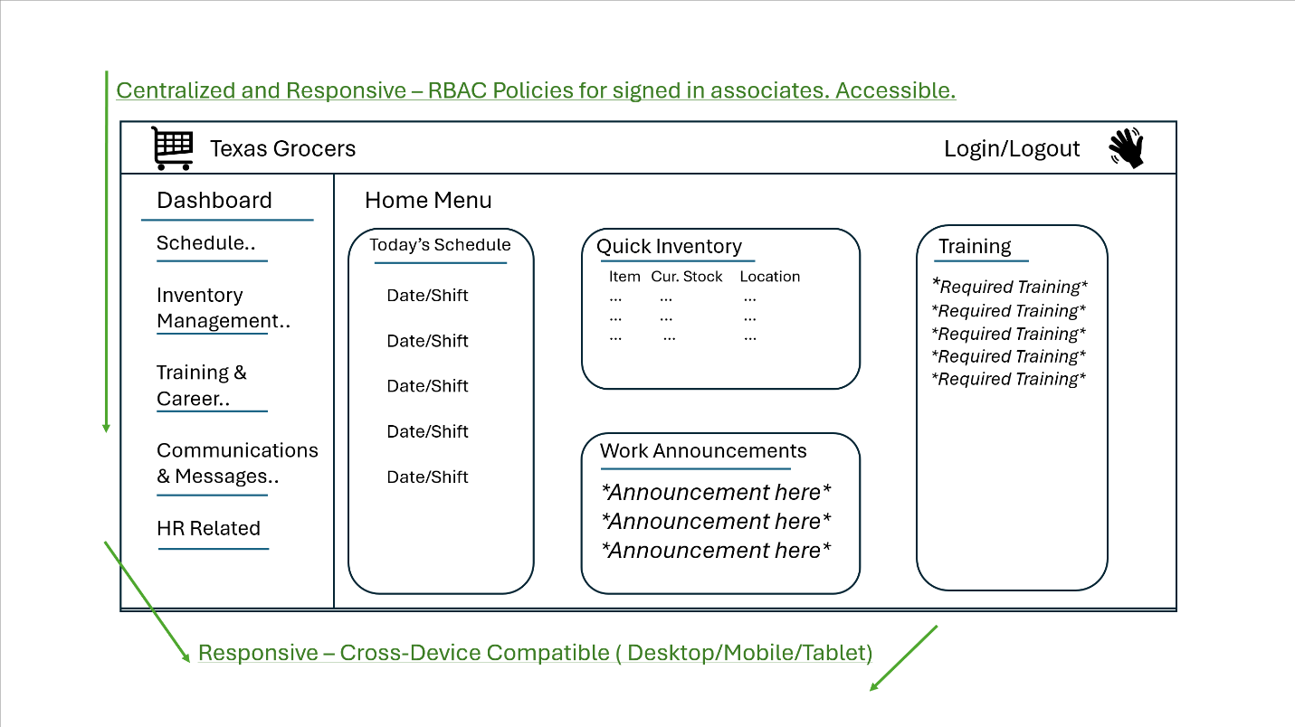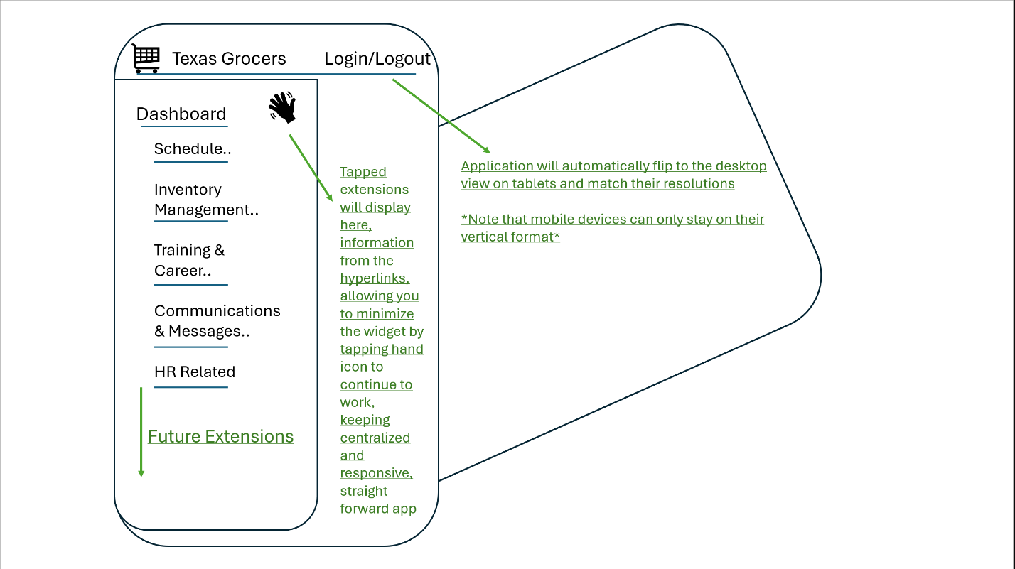

Appendix A contains the project's wireframe for the UI design diagram for the Texas Grocers Workforce Portal. The respective IT team created the artifact during the initial design phase, during the model discovery in week 2. It gives a glimpse of the full, responsive, and centralized dashboard layout, with each employee having a personalized dashboard based on their RBAC permissions. It has a dashboard with scheduling, inventory management, training and career, communications, and HR related material with the ability to expand when needed. The diagram supports goal 1 by serving as a visual blueprint for the branded, cross-compatible interface for associates on their mobile, tablet, or desktop devices.

Appendix B

Network and Systems

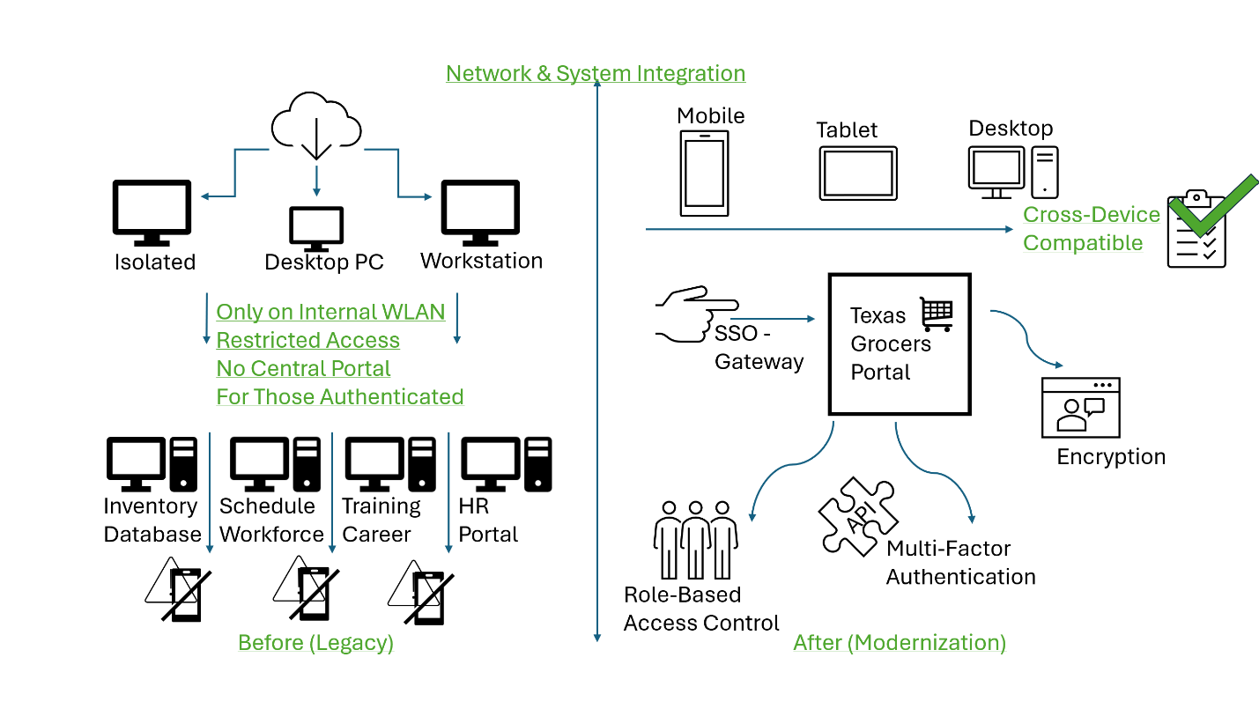

Appendix B is a before-and-after network and systems integration diagram. This diagram was developed during the design and implementation phase to transparently show the company's shift from legacy desktop-only systems to a new, cross-device-compatible, centralized Workforce Portal. It visually displays the SSO gateway, API integration, RBAC, and cross-device compatibility, all of which are directly related to goal 2 and the project's modernization idea.

Appendix C

Training Material Sample

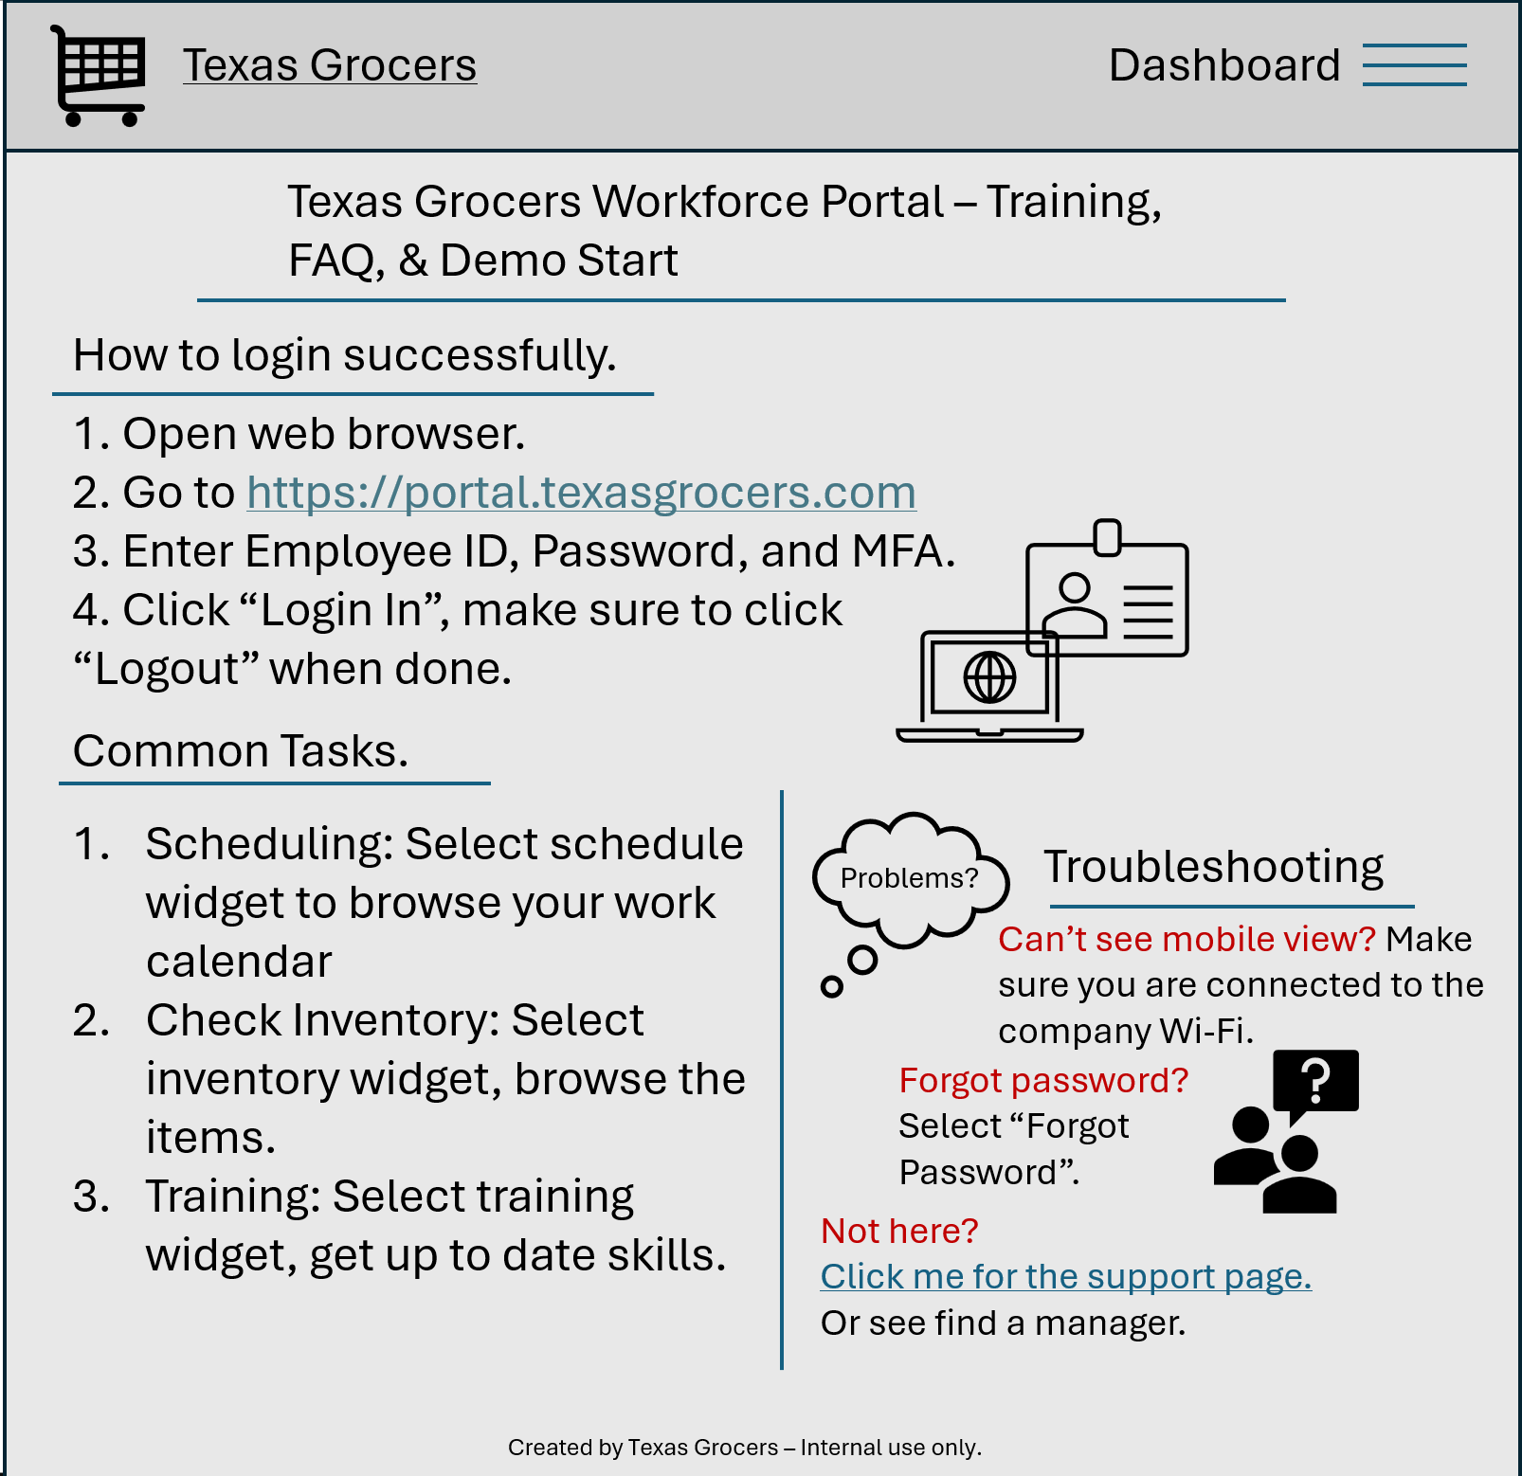

Appendix C presents a sample training page for end users, including a short FAQ and a quick-start guide for associates to access their portal. The short FAQ also provides troubleshooting tips and a link to other issues. The respective IT team finalized the training material samples during week 12 of the implementation phase. It is essential because it provides clear, concise instructions along with troubleshooting tips. Goal 3 is directly supported as it guarantees support for the transition to the new environment.

